**Part 1**

Did you know countries are ranked each year based on a Happiness Index? This index rates the happiness of countries on a scale from 0 to 10, and it's pretty fascinating! Today, we are going to cover exactly what this supposed Happiness Index is, how it is formulated and what you can learn from it!

The 2018 World Happiness Report defines the Happiness Index (or "Life ladder") as follows:

*Please imagine a ladder, with steps numbered from 0 at the bottom to 10 at the top. The top of the ladder represents the best possible life for you and the bottom of the ladder represents the worst possible life for you. On which step of the ladder would you say you personally feel you stand at this time?*

This ladder is known as the Cantril Ladder. It's used in a lot of studies as a simple way to ask people to rate their current satisfaction with life - or happiness. More than a million people worldwide have been asked this question, and the answers have been used to create the yearly Happiness Index.

**The map of Happiness**

**Part 2**

**Data Source - The Gallup World Poll**

The World Happiness Report sources its data from [the Gallup World Poll](https://www.gallup.com/analytics/232838/world-poll.aspx).

Gallup - the organization behind this enormous poll - interviews approximately 1,000 residents per country each year. Gallup interviews these people in over 150 countries around the world. These people are randomly selected, as long as they are registered civilians of the country (non-institutionalized) and aged 15 and older. Each respondent in this happiness survey is asked the same questions in his or her own language to produce statistically comparable results.

In 2019, the Gallup World Poll included Happiness Index data in 156 countries.

According to the Happiness Index of 2019, the happiest countries in the world are:

**Top 10 Happiest Countries 2019**

On the other hand, the unhappiest countries in the world according to the Happiness Index of 2019 are:

**The 10 Unhappiest Countries 2019**

For your information, the average Happiness Index of all the 156 countries is 5.41, which is lower than 50% of all countries.

**Part 3**

**GDP per capita**

Gross Domestic Product - or GDP - is simply the value of all the goods and services a country produces on a yearly basis.

Divide the GDP by the total population of a country and you have the GDP per capita.

This is arguably the most accepted method of determining a country's level of wealth.

The wealth of a country is significantly correlated to its Happiness Index.

Money buys happiness up to a certain degree. Our calculations shows this degree as a 2.22 slop and intercept 3.4

The r-squared is: 0.7938828678781276

The equation of the regression line is: y = 2.22x + 3.4

The p-value is: 4.31548091331933e-35

**Part 4**

**Family Values**

We divide all countries into 4 groups, based on the Happiness Index. First group – top 40 countries, second group – next 40, third group – next 40 and fourth group – bottom 40 countries.

Base on the density plot we can see:

The happiest countries are consistent with the highest family values.

The r-squared is: 0.7423109555885221

The equation of the regression line is: y = 2.98x + 1.81

The p-value is: 8.109320834658085e-27

**Part 5**

**Freedom**

The accompanying charts show that this factor does not have a strong correlation with the Happiness Index. This may be the result of how different people describe freedom.

The r-squared is: 0.6090686158010536

The equation of the regression line is y = 0.58x + 29.84

The p-value is: 5.799447698240429e-15

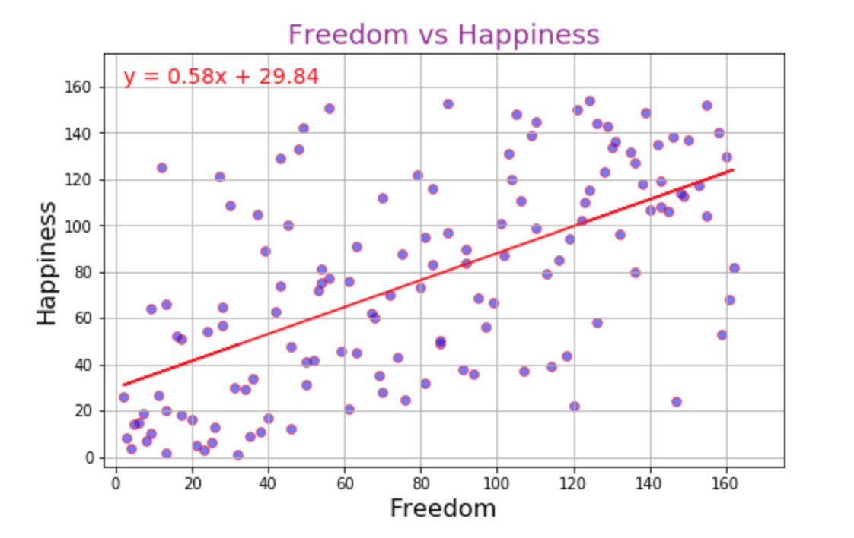

**Part 5**

**Population Density**

It was surprising for our research group to learn that population density has minimal effect on happiness. The bar chart of top 20 countries proves it.

The r-squared is: -0.07282635578685366

The equation of the regression line is y = -0.08x + 81.99

The p-value is: 0.3823573051743563

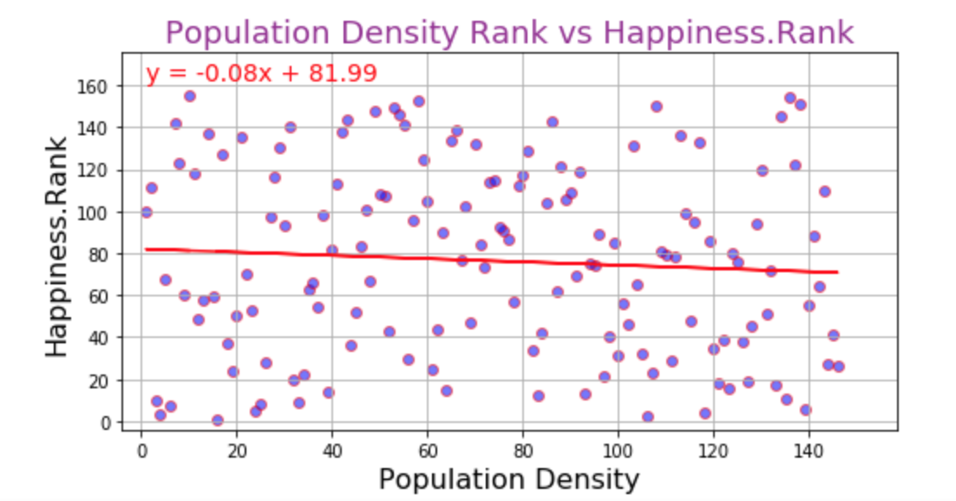

**Part 6**

**Generosity**

Generosity was also determined by the Gallup World Poll survey results, by having respondents answer this question: “Have you donated money to a charity in the past month?". We learn that there is no significant correlation between Happiness and Generosity. This was clearly evident by examining the GDP per capita and their generosity.

The r-squared is: 0.1358247470811378

The equation of the regression line is y = 1.54x + 5.1

The p-value is: 0.09090351257671832

